Give me an image of an AI robot, it needs to be clear. With a beautiful galactic background, and it needs to be holding a laptop in hand.

USER PROMPT

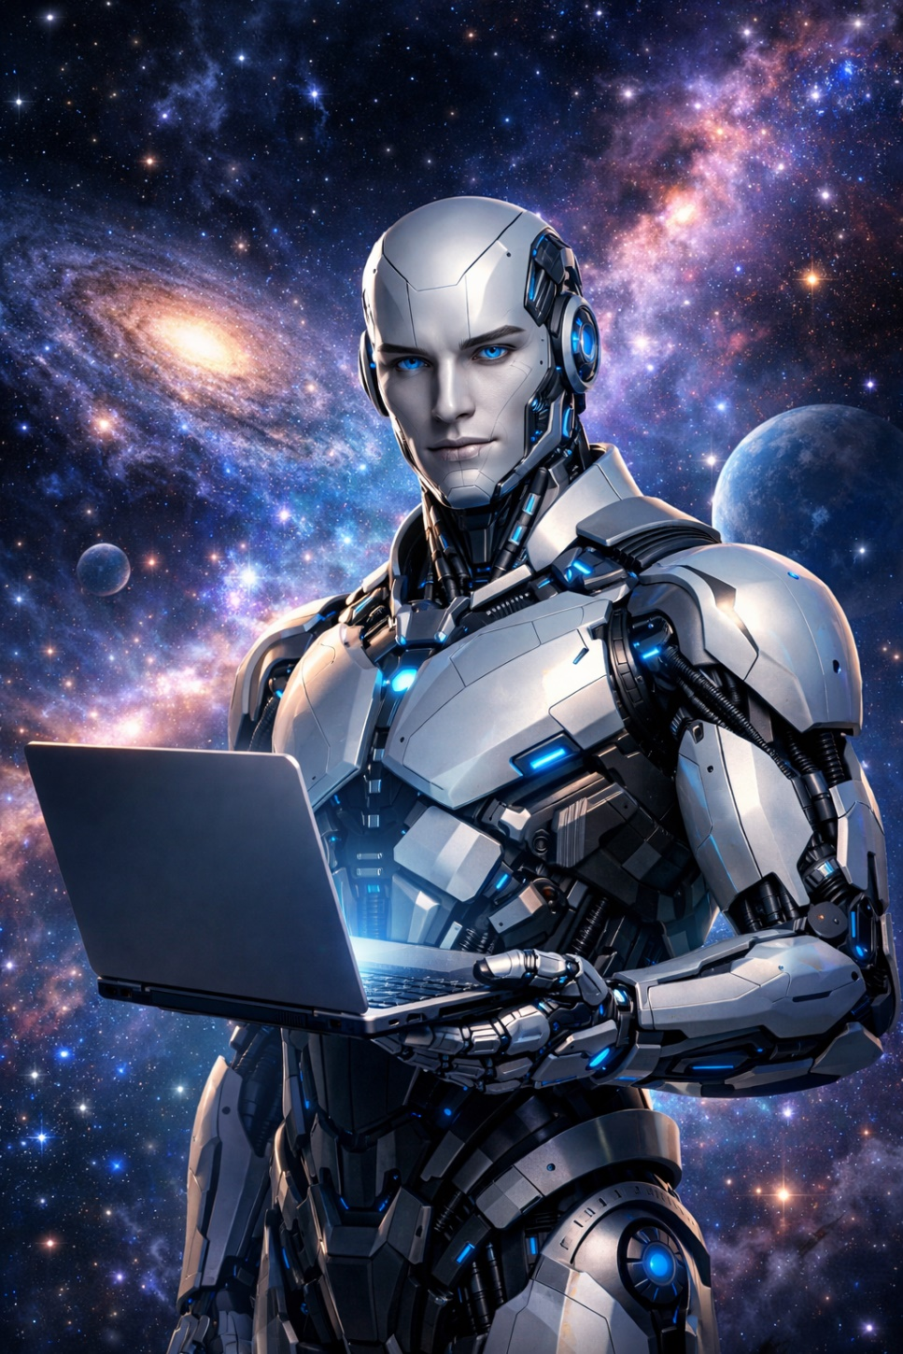

JSON PROMPTING
using JSON prompting method: give me a photo of a AI robot it needs to be clear. I need it with a beautiful galactic background, and it needs to hold a laptop in hand.
{
"prompt": "A highly detailed humanoid AI robot with a masculine build, sleek metallic body, and a fully robotic face with glowing blue eyes. The robot is holding a modern laptop in its hands. The background is a stunning galactic scene with colorful nebulae, stars, and distant planets. Cinematic lighting, ultra-realistic, sharp focus, futuristic, 8K quality.",
"style": "photorealistic",
"lighting": "cinematic lighting with soft glow and reflections",
"resolution": "1024x1792",
"camera": {
"angle": "medium shot",
"focus": "sharp focus on robot",
"depth_of_field": "slight background blur"
},
"details": {
"robot_design": "futuristic, metallic, glowing accents",
"background": "galaxy, nebula, stars, planets",
"object": "robot holding laptop"
}
}
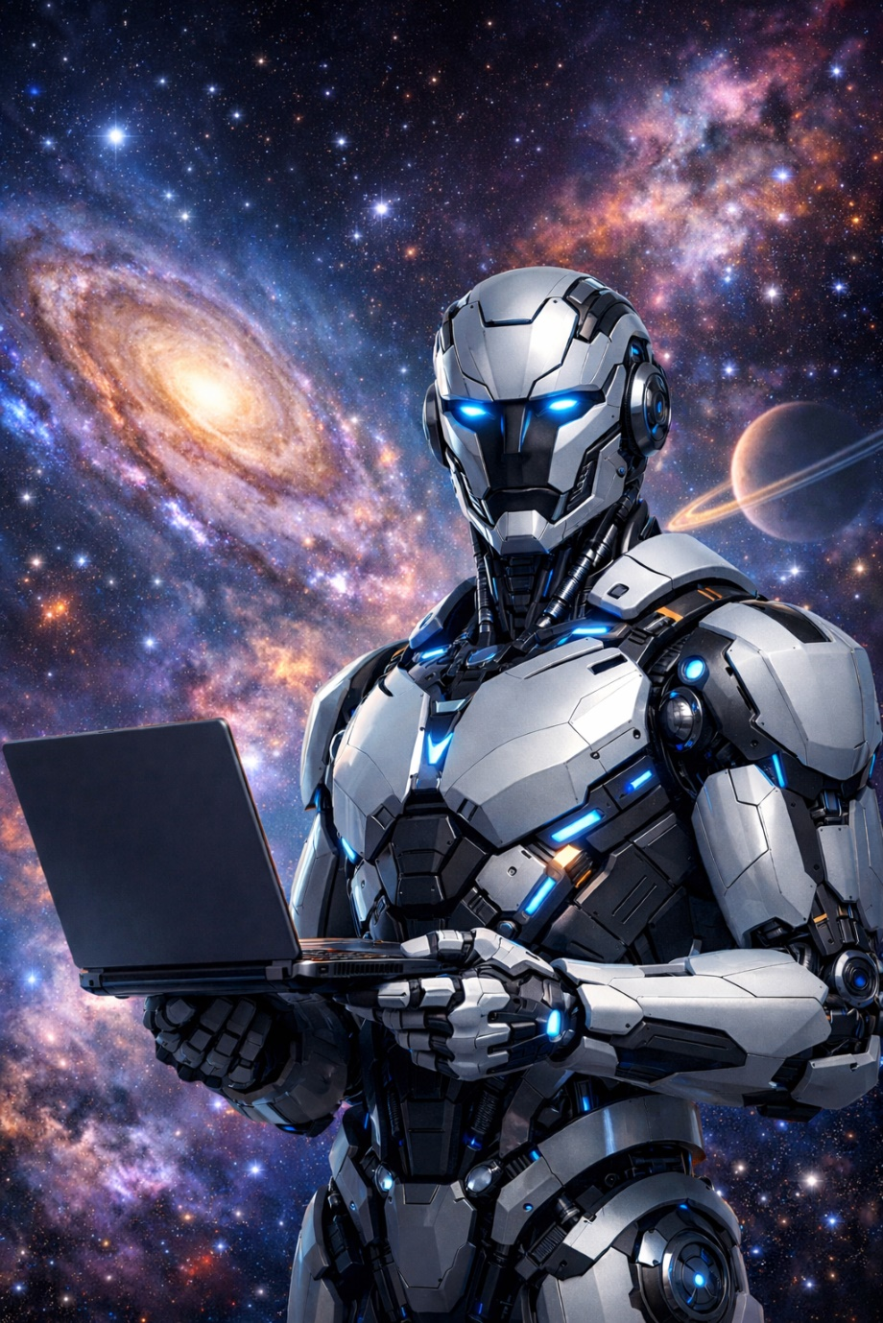

JSON PROMPTING OUTPUT

